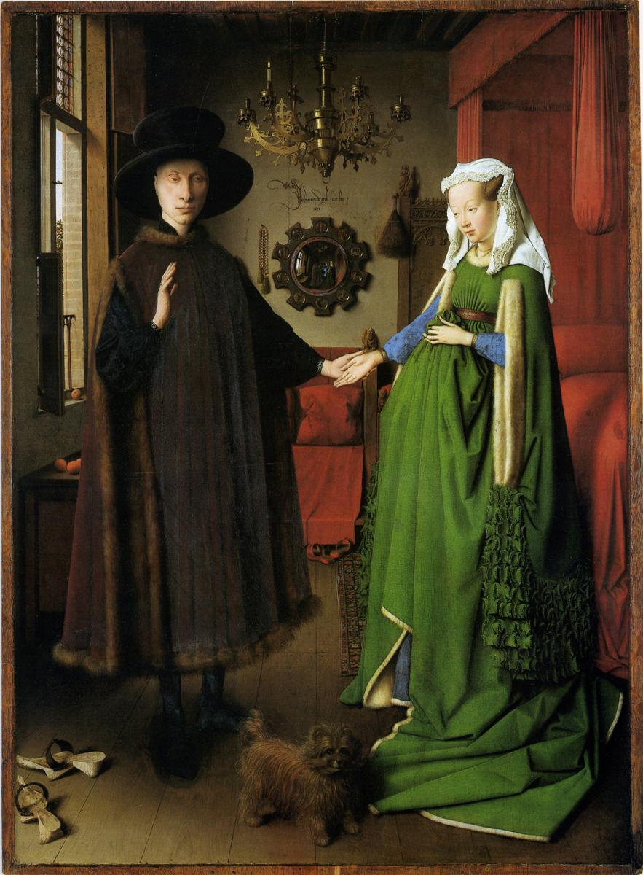
Name: _____________________________ /8

Art History
Observing The Arnolfini Portrait

Jan van Eyck, The Arnolfini Portrait, 1434.

Looking at artworks begins with observation. Think of it as approaching each artwork as a mystery to be solved. What is going on? Why did the artist make this? What is it about?

Like a detective, you will be looking for clues that will help you answer these kinds of questions this semester. Let’s start by practicing our observational skills.

Please list what you see, including their location and appearance:
Example: There are a pair of light brown wooden shoes in the bottom right corner.

1.

2.

3.

4.

5.

6.

7.

8.

